Lab Report No 04
Performance Analysis of Embedded Programs



Spring 2026
CSE-420L Embedded Systems LAB

Submitted By: Naveed Ahmad
RegistrationNo:22PWCSE2154
Section: B

“On my honor, as student of University of Engineering and Technology, I have neither given nor received unauthorized assistance on this academic work”

Submitted to:

Engr. Muhammad Shahzad
March 17, 2026

Department of Computer Systems Engineering University of Engineering and Technology Peshawar

Title: Performance Analysis of Embedded Programs
Latency:
Latency is the time delay between giving a command and the system starting to respond.

Example:
In Arduino, the time between sending a signal to a pin and the pin actually changing state is called latency.

Latency = Response delay time

Throughput:
Throughput is the amount of work or number of operations completed in a given time. Example:
How many times Arduino can toggle a pin in one second.

Throughput = Number of operations per unit time

Objective:
- To measure the execution time of pin toggling in Arduino Uno.
- To compare the speed of digitalWrite() function and Direct Register Access (PORTB).
- To understand how low-level register manipulation improves performance in embedded systems.

Apparatus:

- Arduino Uno R3
- USB Cable
- Computer / Laptop
- Arduino IDE
- LED (optional)

Theory:

Arduino boards use a microcontroller to control input and output pins. The execution time of a command shows how long the microcontroller takes to perform an operation.

- Using digitalWrite()

digitalWrite() is a high-level Arduino function used to set a pin HIGH or
LOW.

Example:
digitalWrite(13, HIGH); digitalWrite(13, LOW);

Advantages:
  - Easy to use
  - Portable across boards Disadvantages:
  - Slower because it performs multiple internal operations such as:
    - Checking pin mapping
    - Setting registers internally

Using Direct Register Access
In this method we directly manipulate hardware registers of the microcontroller. Example registers:
  - DDRB → Data Direction Register
  - PORTB → Output Register

Example:

PORTB |= (1 << PORTB5); PORTB &= ~(1 << PORTB5);
Advantages:

  - Much faster execution
  - Less overhead

Disadvantages:

  - Harder to understand
  - Hardware dependent

Execution Time Measurement
The function micros() is used to measure time in microseconds. Example:
startTime = micros();

After executing code:

executionTime = endTime - startTime;

Circuit diagram Experiment 1:
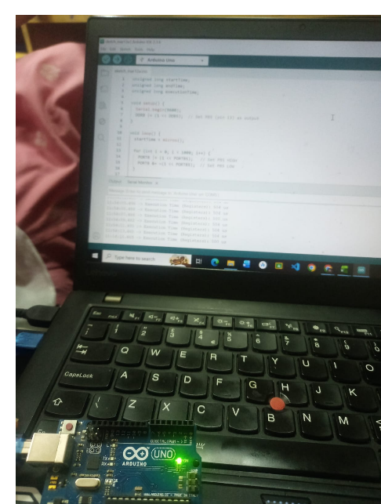

Connections:

  - Arduino Pin 13 → Resistor → LED → GND

Note: Arduino Uno also has a built-in LED on pin 13, so external LED is optional.

Experiment 1: Using digitalWrite() Algorithm:
- Start the program.
- Initialize serial communication at 9600 baud.
- Set pin 13 as OUTPUT.
- Record start time using micros().
- Run a loop 1000 times.
- Set pin HIGH using digitalWrite().
- Set pin LOW using digitalWrite().
- Record end time using micros().
- Calculate execution time.
- Print execution time on Serial Monitor.
- Repeat after 2 seconds.

Source code: unsigned long startTime; unsigned long endTime;
unsigned long executionTime;

void setup() { Serial.begin(9600); pinMode(13, OUTPUT);
}

void loop() { startTime = micros();

for (int i = 0; i < 1000; i++) { digitalWrite(13, HIGH); digitalWrite(13, LOW);
}

endTime = micros();
executionTime = endTime - startTime;

Serial.print("Execution Time (digitalWrite): "); Serial.print(executionTime);
Serial.println(" us");

delay(2000);
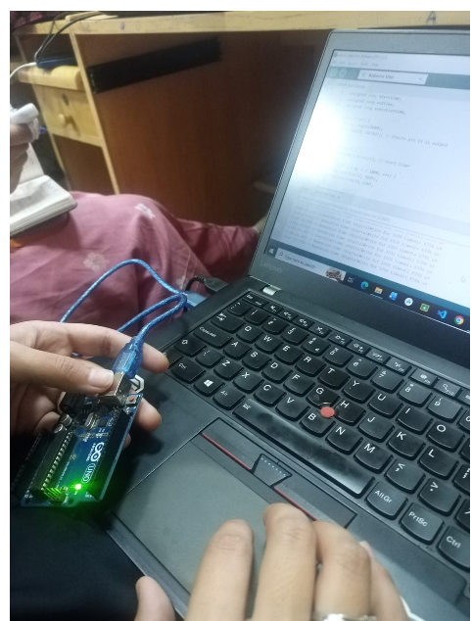}

Experiment 2: Using Direct Register Access Algorithm:
- Start the program.
- Initialize Serial communication.
- Configure Pin 13 (PB5) as OUTPUT using DDRB register.
- Record start time.
- Run loop 1000 times.
- Set pin HIGH using PORTB.
- Set pin LOW using PORTB.
- Record end time.
- Calculate execution time.
- Display the result on Serial Monitor.
- Repeat after delay

Source code:
// Experiment 2: Execution time using Direct Register Access

unsigned long startTime; unsigned long endTime; unsigned long executionTime;

void setup() { Serial.begin(9600);
DDRB |= (1 << DDB5); // Set pin 13 (PB5) as OUTPUT
}

void loop() { startTime = micros();

for (int i = 0; i < 1000; i++) {
PORTB |= (1 << PORTB5); // Set pin HIGH PORTB &= ~(1 << PORTB5); // Set pin LOW
}

endTime = micros();
executionTime = endTime - startTime;

Serial.print("Execution Time (Registers): "); Serial.print(executionTime);
Serial.println(" us");

delay(2000);
}

Procedure:

- Connect Arduino Uno to the computer using a USB cable.
- Open Arduino IDE.
- Write the first program using digitalWrite().
- Upload the code to Arduino.
- Open Serial Monitor.
- Observe the execution time results.
- Now write the second program using Direct Register Access.
- Upload the code again.
- Observe the execution time results.
- Compare both results.

